MACH4METAL

Metalworking machinery
Transito 21,
6909 DA BABBERICH
Netherlands
Tel. +31 (0)316 – 247123
Fax. +31 (0)316 - 247956
info@mach4metal.com
www.mach4metal.com

Account No: 66.52.13.883
IBAN : NL33 INGB 0665 2138 83
BIC : INGBNL2A

CNC Bed milling machine MTE
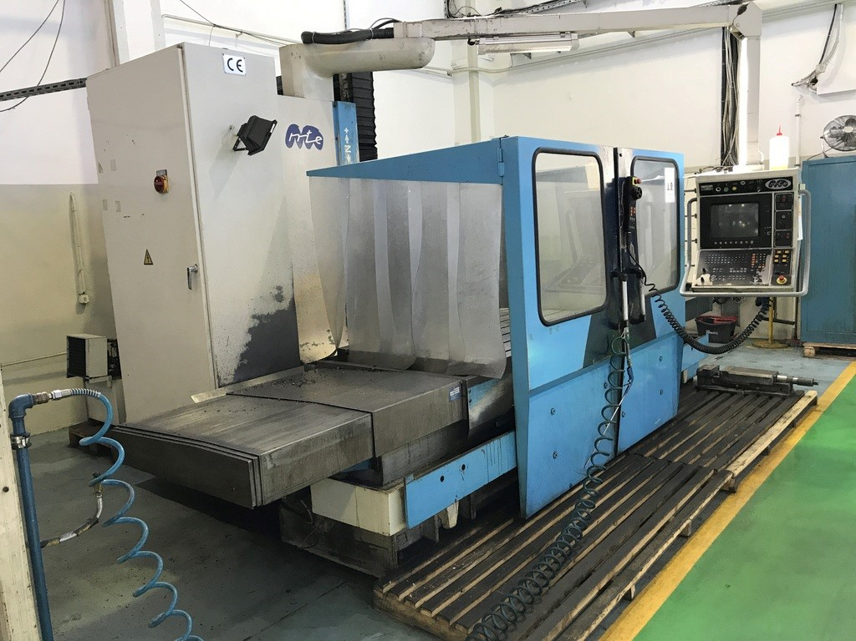
- Make : MTE Spain
- Typ : BF 1700
- Age : 1997
- No. : M ,,,

- Table dimensions
- Length : 1.700
- Width : 1.000
- Work piece Load : 2.000
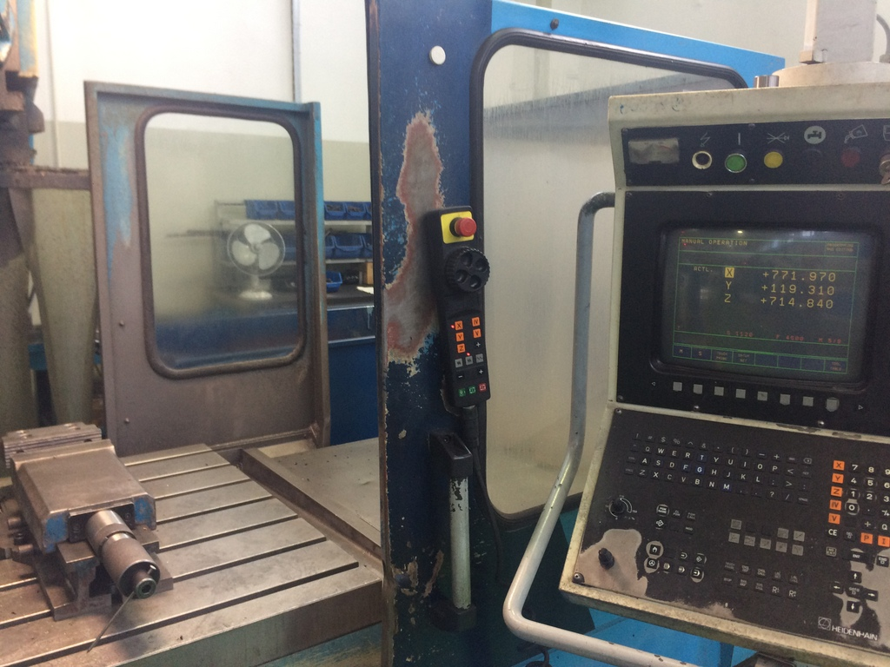
- Movements – Travels:
- X : 1.500
- Y : 1.000
- Z : 1.000

- Spindle : iso 50
- Speeds : 60 – 2.500 Rpm
- Milling head power : 15 kW

- Feeding range : 0,01 – 4.000 rpm
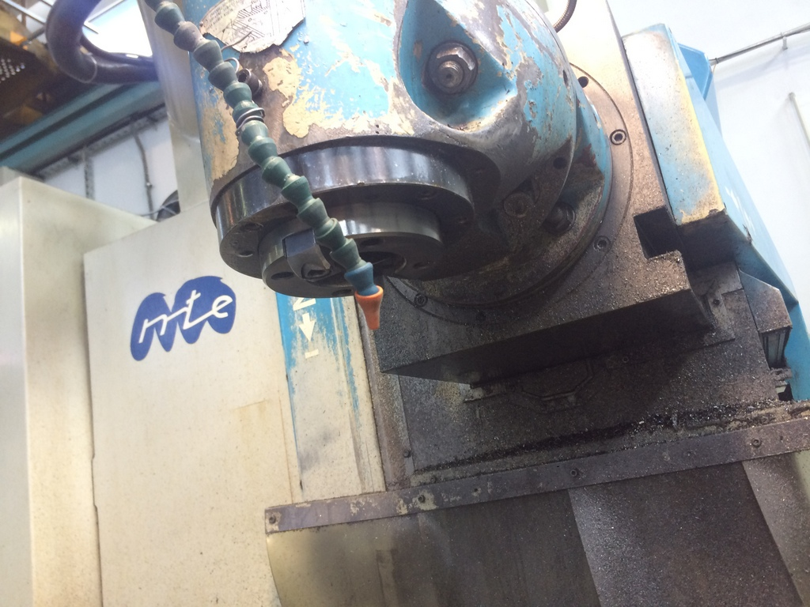
- Rapid traverse : 0,01 – 10.000 rpm

- CNC HeidenHain TNC 426
- Universal milling head
- Hydraulic Tool clamping
- Central lubrication

- Dimensions
- Length : 5.000
- Width : 3.900
- Height : 3.100
- Weight : 8.000

Please Note: The above information has been obtained to the best of our ability and belief from, and from the manufacturers where possible. It is given in good faith, but its accuracy can not be guaranteed. Accordingly, it will not form a representation or constitute contractual terms. We advise you to check any vital details!

